A Touch of Warmth

History of Pen Cai
Traced back to as early as late 13th century China, you may recognize this well-loved Cantonese dish, Pen Cai, that often makes its special appearance during Chinese New Year. Commonly served in a large wooden, porcelain or metal bowl, Pen Cai is a specially curated dish meant to be consumed communally within families and friends.

A prominent characteristic of Pen Cai is the layering of ingredients. This traditional dish is arranged layer by layer and typically consists of ingredients such as white radish, cabbage, fish maw, mushrooms, prawns, ginger and more.

The importance of this well layered dish boils down to the qualities and virtues that Pen Cai symbolizes - unity, equality, family lineages and showing one’s gratitude to family ancestors.

Did you know that you were meant to eat Pen Cai from the top to the bottom, accordingly to the way it has been layered as well?

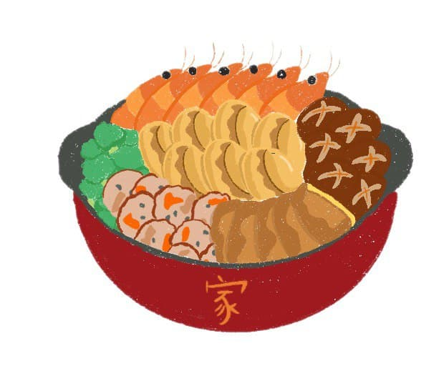
To find out more, come join Claire as she pays tribute to her late grandmother by cooking this sentimental dish!
Pen Cai Recipe
PREPARATION OF INGREDIENTS:
1 can of abalone
*Reserve the abalone water.

1 can of abalone mushrooms

100g of broccoli
Cut into 7 pieces and blanch.

3 cabbage leaves
Chop and blanch.
*When blanching, add in 1 rod of rock sugar.

50g of fish maw
Soak and blanch.

3 cloves of garlic
6 thin slices of ginger

5 red sea prawns
Clean, wash and devein before blanching.

1 roasted duck drumstick

250g of fresh scallops

7 shiitake mushrooms
Rinse and soak for 10 hours or until soft.
Cut stem. Squeeze out water from mushrooms. Reserve soaking liquid.

200g of white radish
Slice into pieces and blanch.
*When blanching, add in 1 block of rock sugar.

SEASONING:
- 1 tablespoon of abalone scallop sauce
- 300ml of chicken broth
- 3 tablespoon of corn starch dissolved in 1 tablespoon of water
- ½ tablespoon of dark sauce
- 1 tablespoon of oyster sauce
- 1 tablespoon of rice wine

PREPARATION OF BROTH MIXTURE:
Boil shiitake mushrooms in chicken broth, abalone water and mushroom liquid. Add in all the seasoning and simmer for 30 minutes in medium heat.
Remove mushrooms and reserve the broth mixture.

LAYERING PROCESS:
1st layer: White Radish
2nd layer: Cabbage
*Add 3 cloves of Garlic and 6 thin slices of Ginger
3rd layer: Fish Maw
4th layer: Abalone Mushrooms
5th layer (most decorative) :
Abalone
Broccoli
Duck drumstick
Scallops
Shiitake mushroom
Red sea prawns

BREWING:
Pour in the broth mixture into the layered Pen Cai and simmer for 10 minutes in medium heat.
Share and tag us on our socials @sgheritagefest !
Pen Cai Recipe given in Courtesy of the Teo Family

